Health Policy Debate
Description: Using the online system, Kialo, students will carry out an asynchronous, online debate about whether laws that regulate personal health behaviors should be enforced. Kialo is a resource outside of the Canvas LMS but has undergone WCAG audit, is formatted for both desktop and mobile devices, is fully compatible with screen readers in Windows and Mac and has an optimized color scheme option to improve visibility for those who are color blind.
To prep students for this activity, the class will examine a variety of health-related policies including seatbelts, smoking regulations, and sales of sugary drinks among others. To respond to the prompt, students will be asked to use resources from class as well as outside sources of support.
The class will be split into groups of six-eight, with each group having their own debate going in the hopes that smaller group debates will provide more opportunity for students to engage in the activity and prevent excess redundancies in responses. Student in each debate group will be randomly assigned to the “pro” or “con” side. The students will have three phases of responses and a final reflection. Their initial task will be to add two arguments to the side they were assigned. Next, they will respond to two arguments (either countering or adding support for) to the opposing side. Finally, they will go back and counter at least one comment left on one of their original posts. After they finish responding, they will use the rating system in Kialo to weight each argument thread based on how much impact they feel they have on making a decision. After the debate process is complete, each student will submit a reflection on the debate and their final thoughts on the debate question, whether laws that regulate personal health behaviors should be enforced.

Learning objective(s):
- Compare and discriminate between ideas supporting and countering the use of policy in public health
- Evaluate strengths and weaknesses of arguments
- Engage in respectful communication with others while discussing controversial issues
- Develop conclusions on balancing personal behaviors with community health via policy enforcement
Assessment: Students will be assessed based on both their contributions to the debate and their final reflection.
Sample of (includes all details and instructions that students would need):

Overview:
For this debate, we will be using Kialo, an online debate facilitation tool. For an overview of how to engage with Kialo, please see this video (note, Kialo is compatible with mobile devices and screen readers on both Windows and Mac, and has a color optimizing settings.
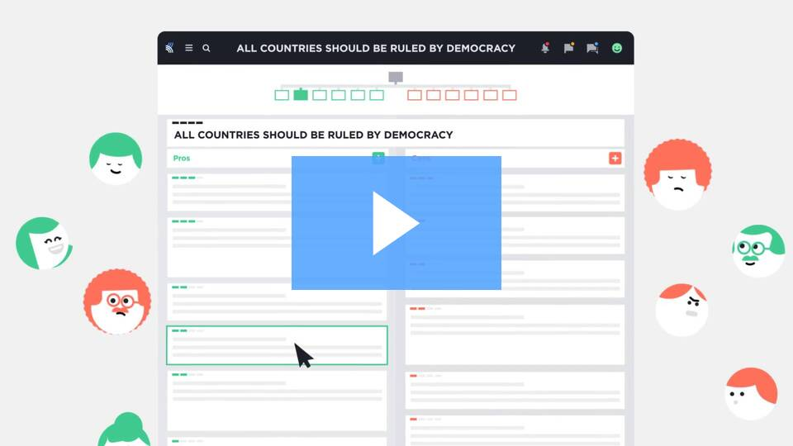
Kialo Edu - The tool to teach critical thinking and rational debate
The thesis for this debate is “Laws that regulate personal health behaviors should be enforced”. For this debate, you will be split into debating groups of 6. Each group will then be split into random teams of three, one team initially arguing on the pro side and the other on the con side. Since the teams will be randomly selected, you may not begin the debate on the side you agree with, that is fine! The arguments you post do not have to reflect your opinion, just sound/prevailing arguments of the people who do agree with the stance. The goal of this debate is not to “win” the argument but to understand both sides. Our netiquette guidelines should be followed thought this debate.

Learning Objectives:
- Compare and discriminate between ideas supporting and countering the use of policy in public health
- Evaluate strengths and weaknesses of arguments
- Engage in respectful communication with others while discussing controversial issues
- Develop conclusions on balancing personal behaviors with community health via policy enforcement

Directions:

Step One: Initial Arguments- Due Wednesday [enter date]
You will be invited to the Kialo discussion set up for the debate your group has been assigned.
Your first step will be to start making arguments. You should create at least two claims that support the side of the argument you were randomly assigned to. Pay attention to the arguments that your classmates are making. If someone has made a claim that you were planning on making, you can provide additional evidence or support for that point in the form of a Pro beneath their claim. Textual evidence from the class readings and links to outside research should both be used to make effective Pros.

Step Two: Follow-Up Arguments Due Friday [enter date]
Once your classmates have added their initial claims, you should start to respond to the arguments on the other side. Read through what the opposing side has posted, and respond to at least two claims (either by adding a con or adding a pro, your choice) to those claims. As long as you meet this minimum, you are now free to add as many claims to both sides as are appropriate.

Step Three: Response Arguments Due Wednesday [enter date]
Now that you all have had a chance to add to both sides of the debate, read through what your classmates who began the debate on the opposite team added to your team’s posts in step two. Read through what the opposing side has posted, and respond to at least one of their claims (either by adding a con or adding a pro, your choice) to those claims. As long as you meet this minimum, you are now free to add as many claims to both sides as are appropriate.

Step Four: Voting and Reflection Due Friday [enter date]
Use the voting feature to vote on the strength of the overall thesis of the debate as well as how well each claim supports it. Think not only about your personal views on the thesis as a whole, but about how strong you judge individual claims to be, irrespective of what side they are on. Use this to help organize your final thoughts about the thesis and complete a reflection that responds to these questions: What did you learn? What challenged you the most? What was the most frustrating part of the debate? Did your opinion stay the same or did you change your mind? Your reflection can be written, verbal, or video format and in the style of a narrative, podcast, poem, or another style of your choice.
Remember, the purpose of this debate is not to win the argument but to engage in the process and think critically. Be sure to look over the rubric before you begin the activity.

Criteria | Mastery | Developing |  | Emerging
Understanding of Topic | Clearly understood the topic in-depth and presented the information convincingly with two initial posts | Understanding of the main points of the topic were emerging and presented with some efficiency with two initial posts |  | Understanding of the topic was not clearly articulated with one or two initial posts
Follow-up to Opposition | Two follow-up points were clearly presented and directly responded to the initial posts showing understanding of topic and sources of evidence. | Two follow-up points were presented with some connection to the initial post but largely off topic. |  | One to two follow-up points were presented with little connection to the topic stated in the initial post
Responses to Opposition’s Follow-up | Once response to a follow-up post was clearly presented and directly responded to the follow-up, showing understanding of topic and sources of evidence. | Once response to the follow-up points was presented with some connection to the follow-up post but largely off topic. |  | One response to the follow-up points was presented with little connection to the topic stated in the initial post
Engage respectfully with your classmates following our class netiquette guides | All posts followed netiquette guidelines and included respectful communication with classmates |  | Any post did not follow netiquette guidelines and did not show respect to classmates
Reflection | Voting process was completed in Kialo and reflection responds to the questions showing an understanding of the thesis and ability to draw conclusions based on evidence provided | Voting process was completed in Kialo and reflection responds to most of the questions showing an understanding of the thesis |  | Voting process was not completed in Kialo and reflection does not respond to questions or show understanding of the thesis

