CSU QLT Course - Instructor Introduction Video

Instructions
- Identify the tool you want to use to create your video.
- Before recording your video, write the script. This is a great opportunity to Be relational, humanize yourself, and facilitate engagement on academic and non-academic matters as Dr. Harris mentioned in the Equity-Minded Practices and Culturally-Affirming Teaching and Learning Practices in Virtual Learning Communities webinar.
Here are some of the things you may want to think about as you write the script for your "Who Am I?" video:
  - Introduce yourself as a person
  - Your passion: why you made your career in your field?
  - Why this course matters to you and how it relates to a student's life outside the course. What topics and themes learned will translate into the outside world.
  - Hobbies or interests outside of the classroom or "instructor" role.
  - Not sure about how long your script should be? This Voice Over Script Calculator
  - Links to an external site.
  - may be helpful.
- Record a short video about yourself and why this course matters. This video should be at least 1-minute in length and no longer than 3-minutes.
- Explore the captioning features in the tool that you selected and the captioning support you have on your campus.
- Share your completed video and script in this discussion for your peers to view. You must be able to share a viewable link and or attach a file. Sharing is a great way to see what others create and gain ideas for your own course. Along with your video, identify the tool that you used and the pros and cons of using this tool. Also, summarize your efforts with captioning and the support services you have on your campus to help with captioning (25 points).
- Provide feedback to at least one peer with insightful feedback that includes ideas for improvement/enhancement (5 points).
Note about captioning: When using video, you should always have any video you create captioned. Additionally, if you decide to use an existing video you will want to only use those that are captioned. You will want to make every effort to caption your 1-minute video. If you upload your video to YouTube, you may enable the automatic caption
Links to an external site.
feature. The captions are created by machine learning algorithms so the captions may need to be edited following these instructions
Links to an external site.
. Try it!
To help you wrap your head around the "Who Am I?" video, see three examples below. Don't forget if you have any questions while doing this assignment please post them in the "Question Cafe." and/or reach out to me directly via the Canvas inbox.

Example 1:
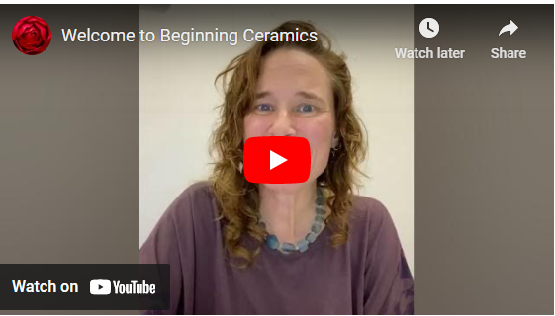Links to Alison Ragguette.
Posted with permission, CSU San Bernardino Faculty

Example 2:
Negin Tahvildary,
Posted with permission, Fresno State Faculty

Example 3:
Elias Pence
Posted with permission, Humboldt State Faculty

