Exploring Inclusivity in the Apparel Industry & Digital Badging Assignment
By Helen Trejo, PhD
Assistant Professor Apparel Merchandising & Management
California State Polytechnic University, Pomona
Learning Objectives
- Gain exposure to a diverse, critical viewpoint based on practices in the global apparel industry heavily rooted in Southern California
- Reflect on inclusive and exclusionary practices in the apparel industry
- Reflect on your experiences applying inclusive practices in a major course project
- Become familiar with the Inclusive Digital Badging and expectations
Instructions
- You can work on this Digital Badging extra credit assignment throughout the semester. It includes viewing a documentary, reflecting in two discussion prompts, responding thoughtfully to peers, and applying key inclusiveness concepts into a major group project for the semester.
- We will use Kanopy, a streaming service that is accessible through the CPP library
- If you complete all parts of the assignment, you will receive a Digital Badge that will be helpful to showcase your competency in Inclusiveness at the Implementation level.
- If you have any questions along the way, please feel free to ask!
QLT Rubric Objectives Addressed
Section 5.1 – The instructor is helpful in normalizing a culturally responsive and sustainable and/or critical lens on course topics, respecting culturally diverse expressions while addressing microaggressions or disrespectful comments.
Section 5.2 – The instructor clearly helps students make connections between the content and the course activities, and how their life experience and master of concepts gained in the course will integrate into their college degree, future career, and role as a global citizen.
Section 5.4 – The instructor empowers students with choices to encourage the exploration of new concepts and new perspectives through the course experience.
Part 1: Choose ONE of the documentaries focused on the global Apparel industry that is heavily based in Southern California. Login by using your CPP username and password.
- Made in LA – 2014 (2 hour, 12 min)
An Emmy award-winning feature documentary that follows the remarkable story of three Latina immigrants working in Los Angeles garment sweatshops as they embark on a three-year odyssey to win basic labor protections from a trendy clothing retailer.
In intimate verite style, MADE IN LA reveals the impact of the struggle on each woman’s life as they are gradually transformed by the experience. Compelling, humorous, deeply human, MADE IN LA is a story about immigration, the power of unity, and the courage it takes to find your voice.
OR
- Maquilapolis: City of Factories – 2006 (1 hour, 8 min)
Carmen Durán works the graveyard shift in one of Tijuana’s 800 maquiladoras; she is one of six million women around the world who labor for poverty wages in the factories of transnational corporations. After making television components all night, Carmen comes home to a dirt-floor shack she built out of cast-off garage doors from the U.S., in a neighborhood with no sewage lines or electricity. She suffers from on-the-job kidney damage and lead poisoning from her years of exposure to toxic chemicals. She earns six dollars a day on which she must support herself and her three children.
Starting in the 1980s the U.S. and Mexican governments initiated a trade agreement allowing components for everything from batteries, IV tubes, toys to clothes to be imported duty-free into Mexico, assembled there and then exported back duty-free as finished consumer goods for sale in the U.S. Tijuana became known as the television capital of the world, ‘TV-juana.’ Globalization promised jobs, and working class Mexicans uprooted their lives to flock to the northern frontier in search of better paying work. After a decades long boom in 2001, Tijuana suffered a recession as corporations chased after even cheaper labor in Asia. When the Sanyo plant where Carmen worked for six years moved to Indonesia, they tried to avoid paying the legally mandated severance pay. Carmen became a promotora, or grassroots activist, challenging the usual illegal tactics of the powerful transnationals that are poisoning their workers and the barrios they inhabit.
OR
- No Sweat – 2006 (53 min)
An all-American tale about an all-American garment: The T-shirt. NO SWEAT takes a wild ride into the bowels of Los Angeles garment industry. Mostly undocumented workers at American Apparel and SweatX are offered better wages, benefits, even a shot at worker-ownership. But what is really behind the label?
Dark, dingy factories. Workers hunched elbow-to-elbow over machines. Nike. Guess. Kathy Lee Gifford. We are all too familiar with sweatshops, operating both in the U.S. and overseas. But does what’s behind the label of what you wear always have to be linked to worker exploitation?
Enter SweatX and American Apparel, two hip T-shirt factories that operate in downtown Los Angeles , just blocks from each other. Both companies are committed to creating “sweat-free” clothing (i.e. their workers earn livable wages and get benefits, work in safe environments, etc). While Sweat X is backed by $2.5 million from ice cream-maker turned social activist Ben Cohen, (of Ben and Jerry’s Ice Cream), American Apparel was built from the ground up by controversial self-described Canadian “schmata” hustler, Dov Charney.
NO SWEAT is a fast-paced, behind-the scenes documentary that follows these two companies for one year, comparing their divergent business practices, interviewing workers, following a union drive, and zeroing in on the hopes and dreams of the garment workers themselves. While Dov gets slapped with sexual harassment allegations and openly resists unionization, Sweat X struggles to survive in the tight economic conditions that have sent so much of their competition overseas.
Part 2: Inclusivity Reflection 1 for Discussion forum
- Which documentary did you select and what was most surprising?
- What are key parts that connect to the course content?
- Did the film create and promote an engaging environment that offers respect to all? If so, how?
- Provide a thoughtful response to a peer – including your reaction, new idea, and any remaining questions
Part 3: Inclusivity Reflection 2 for Discussion forum
- Describe your major project and how you defined success for the project?
- Did you apply key learnings about inclusivity from the film to make your project successful? If so, how? Describe how you used critical thinking, communication, and/or teamwork skills.
- Provide a thoughtful response to a peer – including your reaction, new idea, and any remaining questions
Part 4: Review the CPP Digital Badging website regarding the following:
- What is a Digital Badge?
- Why earn a Digital Badge
- Get Started with Digital Badges!
Digital Badge
CPP Digital Badge | Earning Criteria | Badge
Inclusiveness - Implementer | Implies that all are included in the act of engaging and creating an environment that offers respect to all individuals. These actions may consist of having a diverse set of people all working towards a unifying goal.  Implementer: In addition to exposure to the competency, badge holders should have practice implementing the competency, putting the competency into practice; examples include conducting a project where “critical thinking” is needed; working with others where “communication” and “teamwork” are put into practice; etc. | 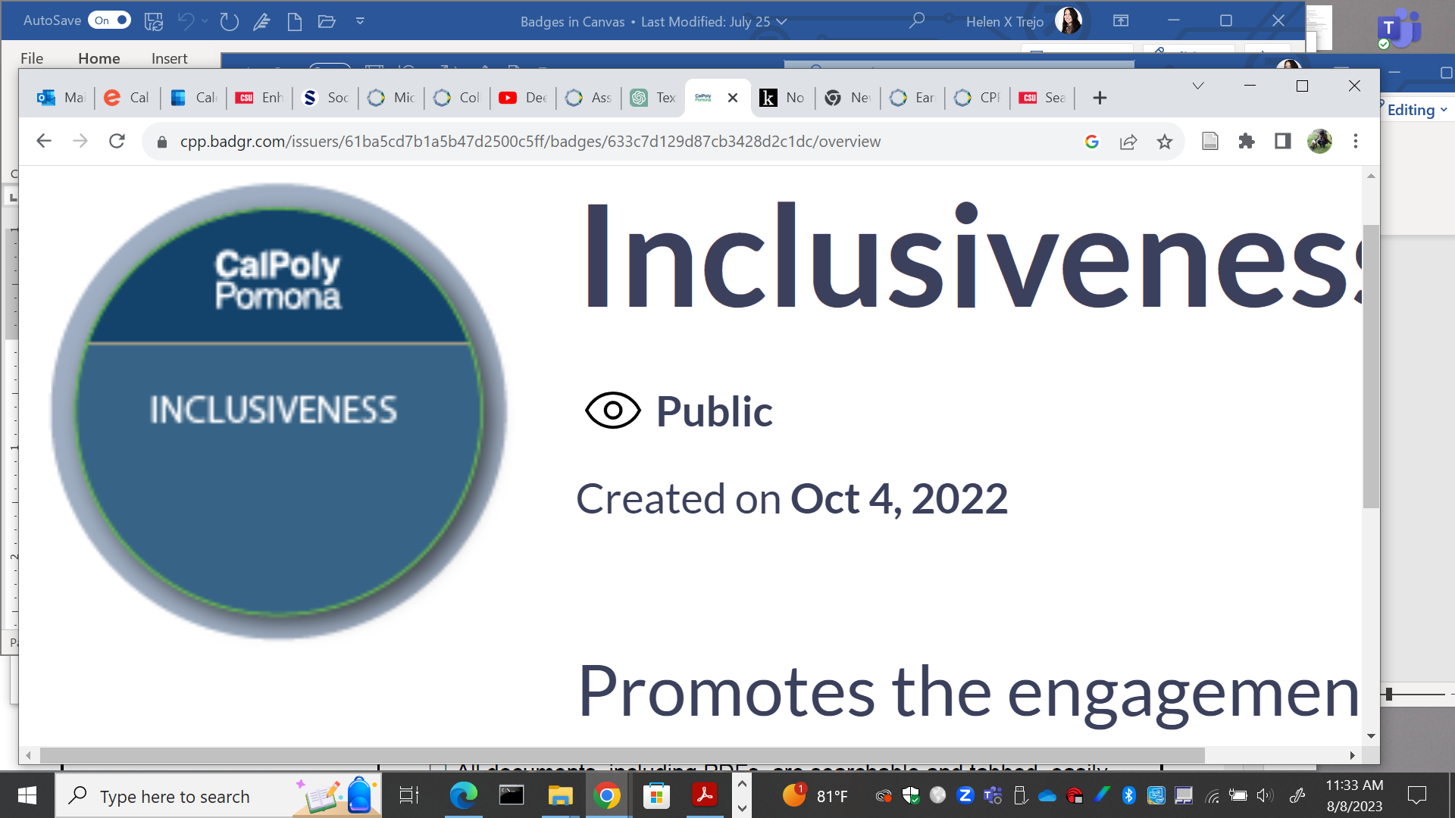

Once all of the activities are complete, you will be awarded a Digital Badge via email.
- Access CPP Badgr account
- Instructions on how to share on Linkedin

